December 27th, 2009
Hi
Not much to write about. Starting last Monday, five high-risk groups can start to get free swine flu vaccinations at selected government clinics. This includes pregnant women, people over 65, pig workers and medical workers. I have an appointment for tomorrow to get my jab. Checked on the Health Dept website and found that the clinic just on the other side of the park is one of them. Starting from tomorrow, private doctors can also give vaccinations. These are not free but are subsidised by the government. But I wonder why would people want to pay for a jab when they get one free at a government clinic?

Last Wednesday, I went to the clinic for a biopsy on my nose. Go back on Thursday to get the stitches removed. Then, outside the clinic, I found a Swine flu vaccination unit that was not listed on the website so decided to get the jab there but was told they were closed “for lunch”. So, on returning to here, called in at the Tin Shui Wai clinic - same thing but got an appointment. Such a hassle when people turn up only to find the clinics are closed when they are announced as being open from 9 am to 5 pm (and at certain times in the evenings).
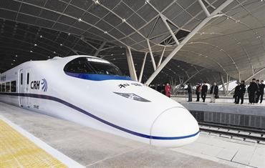
Yesterday, China began its first high-speed train service. The line is from Wuhan to Guangzhau and is 1000 km. The journey takes 2 hours 46 minutes, an average of 332 km/h making it the fastest commercially operated train service in the world. On an earlier trial run, it reached 394 km/h (i.e. nearly 250 mph). These high-speed trains have wheels, unlike the Maglev train from Shanghai to its airport, which takes just 8 minutes. The Maglev train is faster and reaches 430 km/h. Many ‘ordinary’ people however are not too happy as the ticket price is many times the price of the slow train (~10 hours) and the number of slower trains (which run on different tracks) is being reduced.
Yesterday’s run was from Tai Po to lead mine pass to Tai Mo Shan to Route Twisk to Sek Kong - 2 h 40 min which was 2 minutes slower than last year (I see that this time is about the same as it takes the new train in China to cover 1000 km!). Very foggy and windy on the mountain; probably lost time because of it.
A youth orchestra from Perth returned home without getting to perform here and minus two players. Last weekend, the two had bought and a drug mixture at a nightclub and used it in their hotel room that left one of them dead and the other still fighting for his life. So the orchestra decided not to cancel its concert.
That’s about it for now.

Cheers

